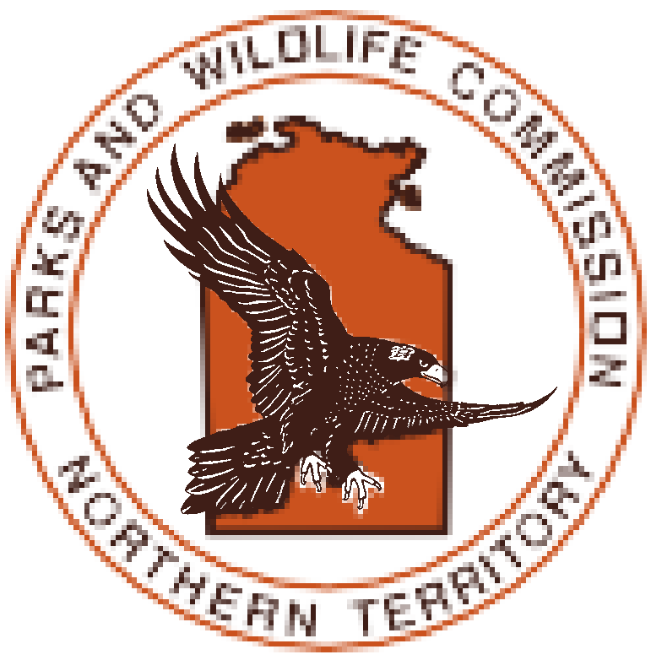
PARKS AND WILDLIFE
Community Engagement Unit
Be Crocwise School Presentation

Background to the Be Crocwise program

Saltwater Crocodiles are, and always have been, serious predators. Co-existing with crocodiles presents challenges to the Territory community.
On the other hand, crocodiles present significant opportunities for both Indigenous and non- Indigenous people in northern Australia.
The Northern Territory Government’s current Crocodile Management Program ensures the long-term conservation of the Saltwater Crocodile and its habitat in the Northern Territory while also keeping the public safe. Its active crocodile management programs include crocodile surveys, trapping and seasonally closing water bodies.
‘Be Crocwise’ is the program’s public safety and education campaign. The Be Crocwise public education campaign is an ongoing program designed to influence and ultimately change behaviour in and around crocodile country and is based on the following principles:
- Saltwater Crocodiles are common in the Territory and pose a significant risk to human life.
- People live and participate in recreational activities in or near waterways where Saltwater
Crocodiles live.
- In areas where Saltwater Crocodiles live, there are no guarantees that a natural waterway is 100% safe.
- Follow all crocodile warning signs.
- Your safety is your responsibility.

REMEMBER
YOU ARE IN CROC COUNTRY

Issues to Consider when Booking a Be Crocwise session

What learning outcomes do you have?
The standard Be Crocwise talk will cover an introduction to crocodiles, the history of human/ crocodile interactions, crocodile biology and behaviour and tips to stay safe in crocodile country.
Talks are best integrated with either lessons from the Be Crocwise teaching and learning kit or other environmental/science based learning topics rather than an isolated talk.
We encourage teachers to use the visit as an opportunity to enhance your students under- standing of the biodiversity of the Territory, and build ongoing importance of the need to stay safe around our waterways.

Which activity best meets your needs?
We are aware that many schools have individual requirements. Community Engagement Rangers are happy to discuss your
requirements and look at providing an activity
to suit your individual needs, where possible.
If the request is not related to the Parks and Wildlife areas of responsibility it may be worthwhile considering an alternative activity provider. Community Engagement Rangers may be able to help you with some contacts.

Have you allowed enough time to prepare and plan for the visit?
We request that all bookings be made at least three weeks in advance.
Due to the large number of schools in the Territory, Community Engagement Rangers can often be booked out so it is advisable to make plans as soon as you know your program.

All activities are free and activity duration is usually 40 mins to 1 hour. If you have different needs please speak to a Community Engagement Ranger to discuss alternatives.

BE CROCWISE - SCHOOL ACTIVITY REQUEST FORM

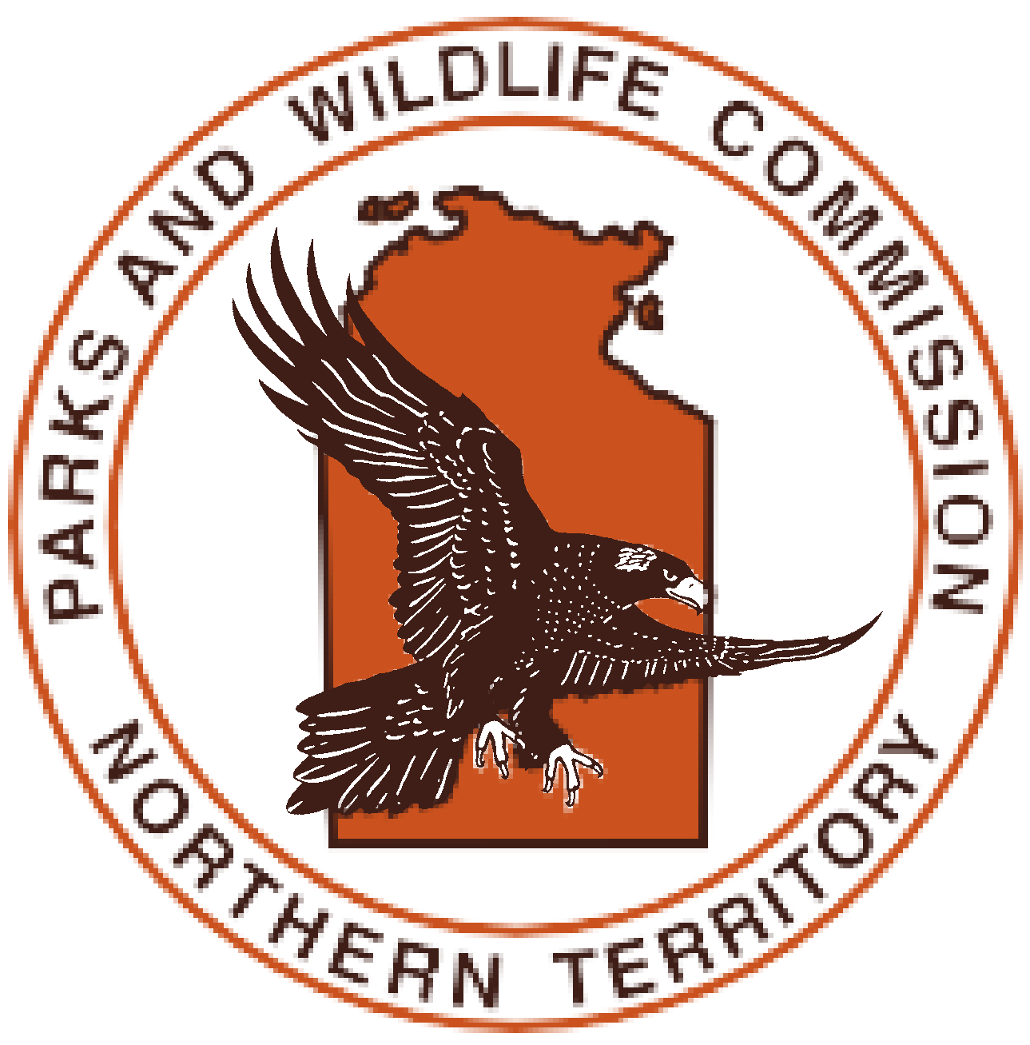
Thank you for your interest in booking a Community Engagement Ranger. We want to help your class gain the maximum benefit from the Ranger’s visit. To do this we need to know your plans well in advance.

This is a request form only. Please complete this form and return it to the Community Engagement Unit (details below). You will then be contacted in regard to a booking.

Name of school: School Principal: Postal address: Street address:
Phone number: Number of students enrolled at this school: Number of students attending presentation:
Date of most recent Be Crocwise talk (if known):

VISIT DETAILS Please note: Juvenile crocodiles are no longer used in classroom presentations.
Person in charge of visit:

Email: Phone:

Group size: Whole school assembly (please tick) (parents welcome)
Class group/s:
(if so, please provide year level/s)

Have you downloaded the Be Crocwise Teaching and Learning Kit?

Date you require a Ranger:
(Please give alternatives in case we are already booked)

- Date: Times - from: to:

- Date: Times - from: to:

- Date: Times - from: to:

Type of visit (please tick): Ranger to Skype / Zoom
school visit session

Please indicate whether the Projector/laptop following is available for use:
Smartboard

VISIT OUTCOMES
What do you want the students to gain from the visit?

What type of pre-visit activities will the students have completed?

What follow up activities will the students complete?

How would you like us to help?

Please Remember:

Rangers are not trained teachers and cannot teach sections of the curriculum. However they can provide opportunities for your class to be involved in observing, recording, discovering and generating an interest in the environment. Throughout the activity, discipline and supervision remain the responsibility of the teacher. Rangers will run the activity but will not be responsible for supervising or disciplining children.

Supervising staff must ensure:

all communication with our staff is respectful, polite and appropriate;
- that behaviour of the group or individuals does not put anyone at risk.

Teachers are also responsible for ensuring all participants in outdoor activities:
- wear a hat, suitable footwear and clothing;

carry and drink water;
- bring healthy snacks for longer activities;

have sunscreen applied prior to the activity.

The Community Engagement Ranger reserves the right to refuse to undertake an activity or terminate an activity if any of the above conditions are not met. This is purely for the safety of participants and staff.

I acknowledge the requirements as stated above and agree to comply with these responsibilities.

/ /

Name Signature Date

Please mail or email this request to the Community Engagement Unit. We will then contact you in regard to a booking.

The information that you provide will only be available to Parks and Wildlife and it will only be used for its intended purpose.
COMMUNITY ENGAGEMENT / BE CROCWISE CONTACTS DARWIN KATHERINE
Community Engagement Unit Community Engagement Unit
PO Box 496 PO Box 344
Palmerston, NT 0831 Katherine, NT 0851

becrocwise@nt.gov.au becrocwise@nt.gov.au

Ph: 8999 4432 Ph: 8973 8865

The information that you provide will only be available to the Department of Environment, Parks and Water Security and it will only be used for its intended purpose. For further information this Department’s Privacy Statement can be viewed at https://nt.gov.au/copyright-disclaimer-and-privacy

